Die Gedanken sind Frei?

Regulating (Neuro)Data Infrastructures

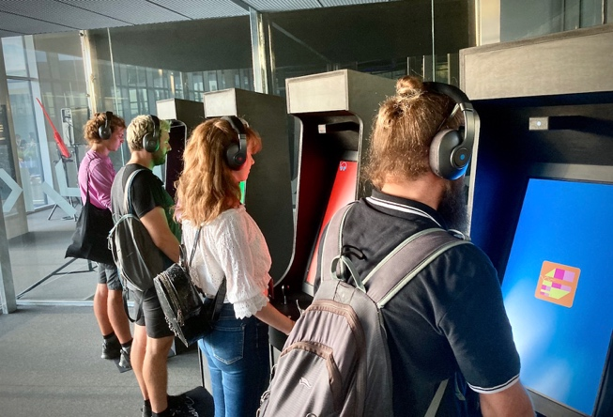
At the IMPAKT Festival in Utrecht in 2023, I encountered Roel Heremans’ NeuroRight Arcades: retro arcade machines fitted with lightweight brain–computer interface (BCI) headsets. The machines responded to the players’ brain activity, translating shifting neural signals into simple on-screen feedback to control a game. The familiar arcade aesthetic contrasted sharply with the ease and speed with which my neurodata were captured and processed. This playful installation worked remarkably well as a tool for public engagement. By embedding neurotechnology into a straightforward, nostalgic setting, it materialised a complex issue: it showed how neurotechnology turns the brain into a direct data source. The “Internet of Bodies”, in which bodily functions and mental states are quietly plugged into digital networks. The question is no longer whether it is possible to turn our thoughts into data, but what happens to autonomy and agency when they are.
Less than a decade ago, much of my research focused on the Internet of Things (IoT), which at the time felt expansive and full of ambitious promises. IoT drove policy debates, investment pitches, and research agendas. For me, this field raised new privacy concerns, new governance questions, and worries about the relationship between everyday life and the companies that design and program the infrastructures underpinning it. But what once seemed pathbreaking has become unremarkable. IoT, with its sensors, home assistants, wearables, smart appliances and, above all, smartphones, is the background of everyday life today. This is domestication in practice, as Roger Silverstone and Sonia Livingstone describe it: technologies that once appeared novel are adapted, woven into familiar routines, and gradually come to feel natural. A process that is cultural as much as technical. Data infrastructures fade from view and data processing ceases to be an active choice and becomes a condition for participation in work, social life, and basic services. We tend to notice these infrastructures mainly when they fail. Susan Leigh Star once wrote that infrastructure sinks into the background as it becomes routine. The IoT is now part of that background.
Roel Heremans NeuroRights Arcade (Retrieved from https://www.werktank.org/nl/projects/82/roel-heremans-the-neuroright-arcades?profile=roel-heremans )
When I encountered Heremans’ work in 2023, neurotechnology felt new to me, but the same cycle was already at work: buzzwords and investment drive curiosity, followed by a gradual embedding into everyday settings. By the mid-2020s, neurotechnology has become a multibillion-euro ecosystem of devices and interfaces that connect physiological and cognitive data streams to broader data infrastructures. Today, neurotechnology spans devices that measure or alter neuronal activity through electrical methods such as EEG headsets and deep-brain stimulation, magnetic techniques like functional MRI or transcranial stimulation, and optical approaches including near-infrared spectroscopy. In 2023, a widely publicised case showed how a BCI combined with generative AI could decode a paralysed woman’s inner speech and express it through a digital avatar. According to a recent UNESCO report, investment in neurotechnology firms grew by around 700 per cent between 2014 and 2021, advancing at a pace comparable to artificial intelligence but with far less public scrutiny. Clinical tools such as deep-brain stimulators and cochlear implants now exist alongside consumer products that promise to track focus, stress, or meditation, and gaming headsets are projected to control drones by thought in the near future. Neurotechnology is moving into living rooms, classrooms, and workplaces.
As Rafael Yuste, chair and co-founder of the NeuroRights Foundation, put it, “That which used to be science fiction, it is actually not science fiction anymore.” (Quoted in The New York Times, 29.09.2024)
The regulation of these devices has not kept pace. A 2024 assessment by the NeuroRights Foundation reviewed the practices of 30 consumer neurotechnology companies and found consistent and systemic gaps in the protection of their customers’ data. Neural data – capable of revealing mental health, emotional states, and cognitive patterns – are widely accessible to those companies. Most of them offer little information about how such data are handled, and the basic principle of data minimisation is rare. More than half of the companies analsysed for the report explicitly allow sharing with third parties, while user rights such as withdrawing consent or deleting data are inconsistently applied. Security measures are often limited. Overall, the sector provides few meaningful safeguards, practices that normalise the routine and high-risk extraction of neural data.
These developments, the rapid investment and the normalization of high-risk data practices, underline a deeper regulatory tension. Neural data are uniquely sensitive: they reflect mental processing and can reveal emotional states, cognitive patterns, and aspects of mental health that users cannot mask or control. Advances in AI will only increase the precision with which such data can be decoded and inferred. Yet consumer neurotechnology devices remain underregulated, and the pace of market growth continues to outstrip legal frameworks. Only a few jurisdictions have begun to respond. In 2024, for instance, California adopted a law that classifies neural data alongside DNA, fingerprints, and facial images under the California Consumer Privacy Act.
For the most part, however, neurotechnology is being standardised and embedded by companies whose primary incentives are commercial. As with IoT, the infrastructure sinks into the background, and the technical systems themselves – the devices, algorithms, and classification models – become de facto regulators of everyday life.
They become regulatory data infrastructures: our societies are increasingly governed through data infrastructures that do not merely store or transmit information but organise, identify, classify, and act. Regulatory data infrastructures shape who is recognised how, how people are categorised, and who gains access to services, welfare, or rights. With neurotechnology, the datafication logic becomes particularly intrusive. Behaviour, identity, attention, and emotional states become part of this governing apparatus. When neurodata infrastructures are domesticated and naturalised, they condition how agency is formed, expressed, and interpreted. In that sense, neurotechnologies is another example of regulatory data infrastructures that begin as experimental innovation but quickly turn into preconditions for participation in society.
And consequences are not distributed evenly. Neurotechnologies are being layered onto existing infrastructures of exclusion and inequality, and they are likely to reproduce and amplify them. For those who are marginalised, stigmatised or criminalised, this is not an abstract concern. Consider a context in which homosexuality is a crime. Now imagine that your headphones, your gaming headset, or your meditation band quietly record moments of desire, fear, shame, or joy, classify them as data points, and store them on commercial servers, where others may claim or buy the right to access them. A device marketed as a tool for focus training or mood tracking becomes an instrument of existential surveillance and control.
The future has arrived, as is always the case, and it is a future that is technically mediated, commercially owned, and politically under-regulated. It raises serious questions about how autonomy and agency can be protected when the infrastructures that shape them are largely outside public control. In such a world, the old reassurance that Die Gedanken sind frei [thoughts are free] begins to sound less like a fact and more like something that will have to be actively defended. But there are ways to push back. Advocacy groups and scholars have proposed “neurorights” to protect mental privacy, cognitive liberty, and the right to self-determination in the face of neurotechnology. Data-protection frameworks can be extended and enforced to treat neural data as exceptionally sensitive, limiting extraction, profiling, and commercial reuse. Public institutions and civil-society actors can prioritise collective oversight, democratic accountability, and meaningful participation over commercial exploitation. Regulation will not solve everything, but it can make a significant difference to who sets the terms under which neurotechnology enters everyday life.

Silverstone, Roger, Hirsch, Eric (Eds.) (1992). Consuming Technologies : Media and information in domestic spaces. London/New York: Routledge; Livingstone, S. (2002). Young People and New Media: Childhood and the Changing Media Environment.
https://www.unesco.org/en/articles/ethics-neurotechnology-unesco-adopts-first-global-standard-cutting-edge-technology
https://www.nytimes.com/2024/09/29/science/california-neurorights-tech-law.html?searchResultPosition=1
https://perseus-strategies.com/wp-content/uploads/FINAL_Consumer_Neurotechnology_Report_Neurorights_Foundation_April-1.pdf

