Governance by Infrastructure:

The DATAGOV Project Kick-Off
26-27 March 2026 by Yelyzaveta Terentieva, Jonas Breuer, Giulia Campaioli #DATAGOV #KickOff #Biometrics #DigitalID #DigitalHealth #Edtech #Infrastructure
<p>On 26 and 27 March, the DATAGOV project held its Kick-Off event in Amsterdam. The DATAGOV project explores the intersections of data infrastructure, governance, and democratic participation in the digital age to study how data infrastructures shape democratic life.</p>
The two days revolved around the question that is core to the project: What happens to democracy when governance is embedded in infrastructure? The project team had invited ten scholars from around the globe working on data infrastructures and governance and asked them to think together. What the event produced was not consensus, but an open conversation in which different perspectives were put forward, challenged, and reworked together.</p>
<p>Biometrics, digital identity systems, and health and education technologies are the regulatory data infrastructures the DATAGOV team focuses its research on: systems that acquire regulatory power through algorithmic decision-making. These systems have become regulatory, they govern parts of the polity. They decide who counts, who gets access, and what proofs an identity. They operate on another level than politics, below the threshold where democratic argument could begin. The question is no longer only who governs, but <em>how</em> governance is coded, performed and who creates and controls these infrastructures. </p>

Day 1: Mapping the Terrain
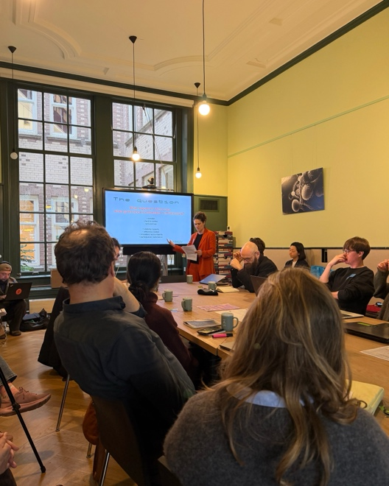
DATAGOV Opening at the Institute for Advanced Study, University of Amsterdam

<p>The first day was structured around two closed sessions with the project team and the invited experts. The first session opened the project’s central question about the future of democratic life in relation to data infrastructures. Visibility, efficiency, accountability and participation were discussed not as problems to be resolved, but as conditions that are there to stay.</p>

<p>Mirca Madianou, professor in the Department of Media, Communications and Cultural Studies at Goldsmiths, University of London, drew on her work on techno-colonialism and digital infrastructures in humanitarian operations. She discussed how humanitarian systems can become forms of infrastructural violence based on her research in refugee camps in Thailand, where iris scanning is the only way to receive food or medical care. Jo Pierson, who is a professor of Responsible Digitalization at Hasselt University, Belgium, pushed back on the public-is-good versus private-is-bad binary: in Belgium, one private “smartschool” platform reaches 90% of schools. He provoked that the real question is whether necessary systems can serve public ends without eroding public infrastructure. Cecilia Passanti, whose PhD examined computing, state-making, and citizenship in West Africa, drew attention to biometric voting in Africa. With her research of a “biometric computer” built in Senegal in 1978, she reopened a colonial genealogy often interpreted as a post-9/11 phenomenon. Niels ten Oever, professor at the University of Amsterdam and co-principal investigator of the Critical Infrastructure Lab, called for abandoning “the stack”, the way we should already have abandoned “the cloud”, because both terms obfuscate power relationships. Marjolein Lanzing, professor of Philosophy of Technology at the University of Amsterdam, named data infrastructures as a new constitutional layer of society that we still talk about as tools.</p>

<p>The interventions sparked a discussion that refused easy answers. The public/private binary, already complicated by the opening provocations, unraveled further: the Netherlands itself was produced by companies and infrastructures, yet with strict democratic controls. "Publicity" emerged as a more useful framing than transparency or accountability for understanding what public action should look like. A sharper historical lens complicated things further: states are often founders of the industries that later become their landlords. And if communities are to be meaningfully involved, that involvement must go beyond the performative, and remain open to the possibility of opting out. A note of caution closed the exchange: however useful the historical continuities, we should not underestimate the distinctiveness of this moment, in which the logics of sovereignty and market are powerfully coalescing. <p>

<p>Next, Louise Amoore, professor of Political Geography and director of the Leverhulme Centre for Algorithmic Life at Durham University, UK, questioned whether public data can be protected from Big Tech while remaining dependent on Big Tech infrastructures. She pointed to the UK and Brazil as examples of states effectively handing public data to private cloud infrastructure. Rob van Kranenburg, founder of the IoT Council and #iotday and author in digital innovation and IoT, recalled how little considerations of data governance were built into data-based infrastructure, with the example of the 2000 Bali “disappearing computer” conference. He reminded the room how important it is that values are embedded in infrastructure from the design stage. Fernando Filgueiras, professor at the Federal University of Goiás, Brazil, and director of Innovation and Digital Strategy at the Brazilian Ministry of Education, showed how Brazil’s cadastro único algorithmically decides who counts as vulnerable and who is entitled to welfare. Rocco Bellanova, professor at the Vrije Universiteit Brussel and principal investigator of the ERC project DATAUNION on European database interoperability set of with a provoking quote: democratising AI is like trying to democratise weapons manufacturing in the service of peace. Bidisha Chaudhuri Assistant Professor of Government, Information Cultures and Digital Citizenship at the University of Amsterdam named the tension that held the room together, between domain governance and governance by data, and warned that “public”, “private”, and “sovereignty” are being reused by the actors pushing for more infrastructure.</p>

<p>The interventions opened onto a discussion circling back to accountability and its limits. The concept of "task-agnostic" AI, borrowed from computer science, was identified as quietly reshaping governance: once AI is no longer tied to specific functions, the boundaries between domains of government begin to dissolve. Explainability was raised as a potential remedy, but also that we are now in a situation where developers themselves cannot explain their systems. What remains possible, and necessary, is a meaningful account of how these technologies transform forms of governance, rather than of their inner workings. Publicity of action was revisited as a question that may apply to AI. Closing the exchange, a question was raised: is it even possible to take control of the paradigm before the paradigm takes control of us? <p>

<p>In the afternoon, the participants moved to three breakout tables, on biometrics, health, and education technologies. These topics are the terrains of which DATAGOV’s PhD researchers and postdoctoral researchers work. Sruthi Vanguri works on digital public infrastructure and digital IDs in India and the EU. Carina R. Nasser studies classification infrastructures, with a focus on Brazil’s national ID system. Mattéo Bard works on EU database infrastructures, interoperability, and innovation ecosystems. Giulia Campaioli investigates digital health strategies in Brazil and Italy, and Jonas Breuer studies how data technologies shape cities, rights, and collective futures. In this session we moved from concerns, dilemmas, and provocations of the first session to channel them into actual research questions and areas of exploration.</p>

<p>In the follow-up of the breakout tables, the main tensions and research directions were brought to light. The healthcare table shared concerns about well-being data, such as mental health and fitness data, which currently falls outside GDPR protections for health-related data, creating a less regulated space for collection, use, and marketisation. The education table focused on the tension between educational values such as access, equality, and affordability, and the reality of scarce resources, especially in contexts characterized by deep inequality, which edtech often promises to solve as a technical problem. Infrastructural violence as introduced by Mirca Madianou, however, illustrates how such systems also produce harm. The biometrics and digital ID table reported on how the real issue was not whether people should be allowed to opt out, but why biometrics are becoming normalised in everyday life at all: citizenship has shifted from something the state owes you, to something you must continuously prove.</p>

Day 2: From Research Questions to Public Concerns

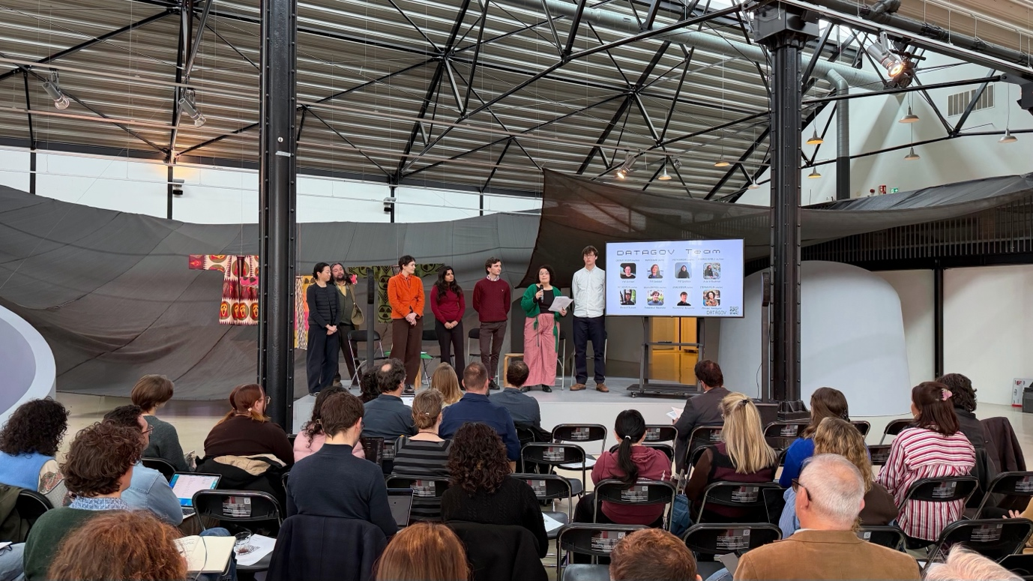DataGov Team at Framer Framed

<p>The second day moved to Framer Framed, an open contemporary art and cultural space where thinking can flow freely rather than put into boxes. The day was organised around two keynotes, each followed by a panel discussions and questions from the audience. Around a hundred scholars, students, interested citizens, artists, government officials and more filled the room.</p>

<p>The first keynote of the day was given by Louise Amoore, who focused her speech on AI, cloud infrastructure, and the transformation of the state. The panel continued the discussion of AI, databases, infrastructure, and resistance, with Rocco Bellanova on the legacy of European interoperability, Mirca Madianou on the infrastructural violence of algorithmic aid decisions in refugee camps, and Niels ten Oever refusing the framing of resistance, suggesting to take an anti-AI position instead. One question from the audience came from Alex Gekker, professor at the University of Amsterdam, who asked the panel to think about the idea of the “minimum viable state”: if the boundaries between the state, NGOs, and private actors dissolve into shared infrastructural dependencies, what happens to the people who rely on those services when government changes? </p>

Panel discussion at Framer Framed, with audience seated and art installation visible on the left

<p>The second keynote was given by Fernando Vilgueiras, who spoke about Brazil’s national education data infrastructure, the IND, established by law in October 2025. IND coordinates educational data across the federal government, 26 states, and over 5,000 municipalities, turning what Fernando called a “regime of collaboration” into an “informational regime”. Coordination now depends on the ability to share data, align systems, and operate interoperable platforms. His closing line captured the wider DATAGOV concern well: “Digital transformation is not technological determinism. It is a political choice.” This reminded us that infrastructures may look boring and administrative, but they actively reshape power. </p>

<p>The second panel shifted the discussion to digital public infrastructures, as Bidisha Chaudhary turned to the changing nature of statecraft in India. Cecilia Pasanti spoke about digital identity and its links to biometric and colonial histories, and Rob van Kranenborg pointed to Europe’s 85 percent dependency on US hyperscalers.</p>

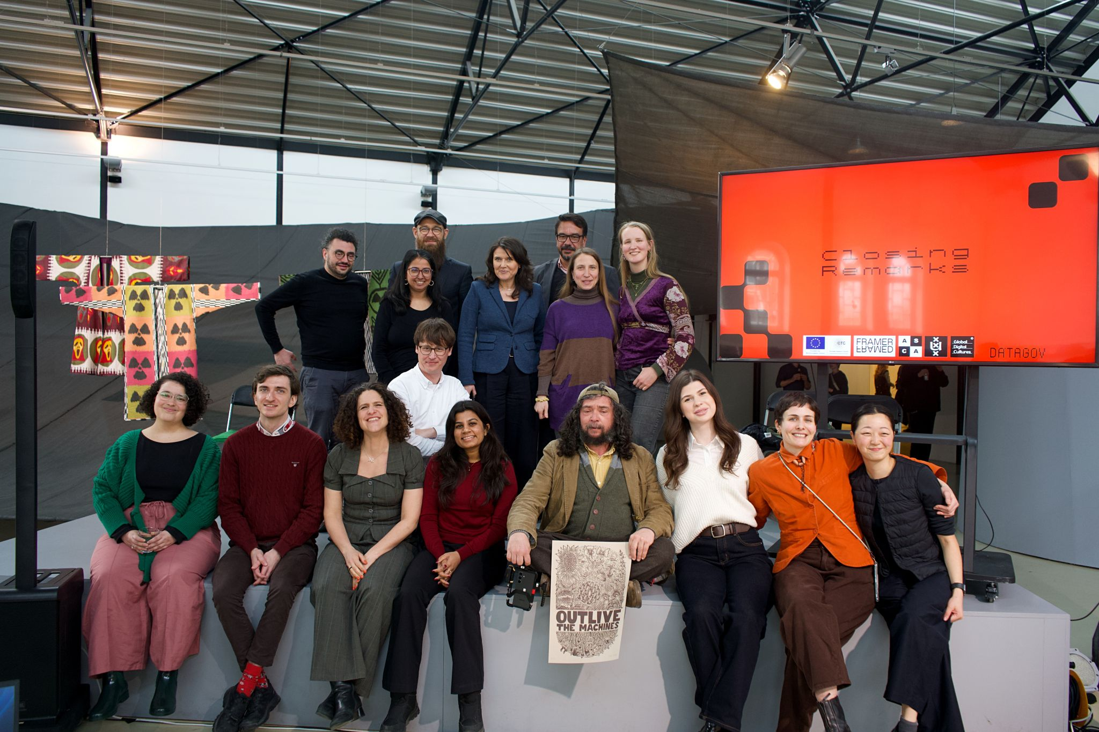
DATAGOV Team with Speakers and Volunteers

What opens up for DATAGOV?

<p>One argument resonated throughout the event, both on and off stage. It is the one Marjolein Lanzing shared on the first morning: data infrastructures have become a new constitutional layer of society, and we still talk about them as tools. That gap between what these systems actually do, how we describe them, and what it means for Democracy is where DATAGOV begins.</p>

<p>These two days were not meant to produce conclusions. They were meant illuminate the many questions for DATAGOV to work on. If distributed architecture does not prevent centralised control, what does? If transparency is insufficient, how does accountability look like when the decisions are made by infrastructures with regulatory power? And if participation sometimes means refusal, if communities may not want to join the digital infrastructure domain at all, are governments ready to take that response seriously?</p>

</p> The urgency of these questions is not abstract. It is built into the infrastructures shaping our lives right now, and we are looking forward to the coming years of this project, which could not be better timed.</p>

