How to claim your costs (non-employees)

Go to https://expenseclaims.uva.nl
Fill your details: Personal Information and Bank Details.

Fill the Cost Centre or WBS-element section as follows: 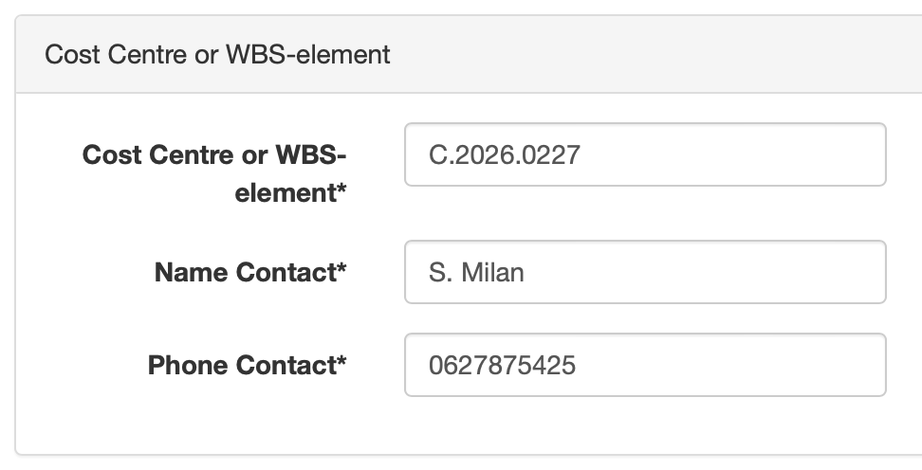
Then as follows. Select “Travel and accommodation costs (NL)”

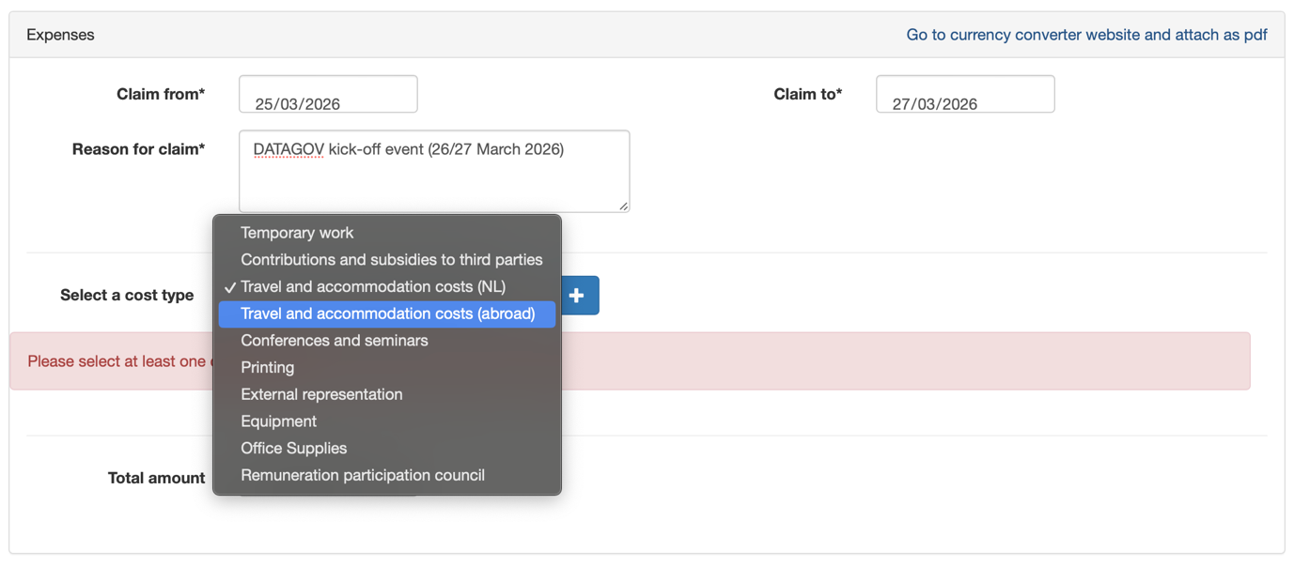

Don’t forget to attache the currency converter document (if appropriate) and the proof of purchase, tickets and boarding passes (if appropriate).

In case of doubts, drop a line to s.milan@uva.nl.

