**Call for Applications**

‘Digital Literacies and Social Inclusion in Brazil’  
An interdisciplinary workshop

**13th – 15th July, 2021**

**Fully online**

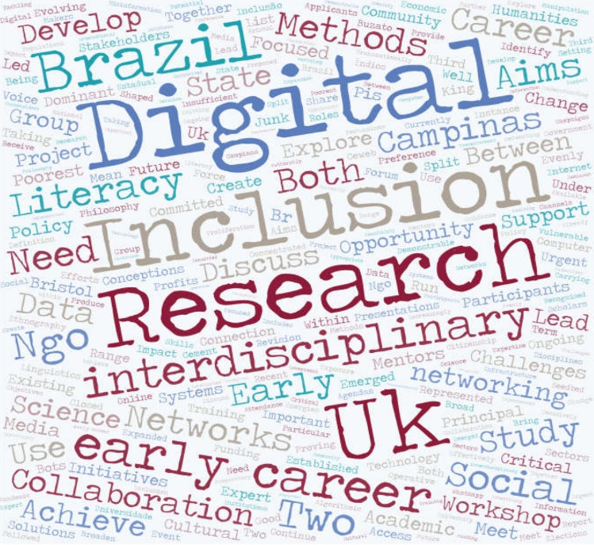

This workshop will bring together early career researchers based in Brazil and the UK working at the intersection of emerging digital literacies and social inclusion. Particular attention will be paid to the use of creative and cross-disciplinary methodologies to explore these urgent issues. Participants will be invited to discuss their work together with both established researchers in the field and representatives of Brazilian NGOs working on digital inclusion initiatives in Brazil. The workshop is funded by a British Council – FAPESP Researcher Links Workshop Grant. The main aim of the program that sponsors the workshop is to stimulate longer term links between early career and senior researchers from the UK and from Universities in the State of São Paulo, Brazil, as well as to contribute to the personal and professional development of the participants.

FOCUS

The dominant conceptions of ‘digital literacy’ and ‘digital inclusion’ are in urgent need of revision. Both governmental and non-governmental organisations working in Brazil have long recognised the importance of information technologies to citizenship and social inclusion. While the state has concentrated efforts on infrastructure and access (principally through the ‘Inclusão Digital’ initiatives launched in 2003), non-profits have focused energies on the use of the internet to give voice to under-represented communities (for instance, the ‘Índios Online’ project launched in 2004). While these agendas continue to be important, they are proving increasingly insufficient when connection to digital networks, which has intensified during the response to the Covid-19 pandemic, can often mean exposure to misinformation or manipulation, with the poorest populations being the most vulnerable. Without an expanded definition of digital literacy that includes a critical understanding of these systems, digital inclusion will not effectively support social inclusion.

The workshop will create an opportunity for early career researchers based in institutions in the State of São Paulo, Brazil and the UK from across the humanities and social sciences, and also other fields that are relevant to the topic, to discuss solutions to these challenges with both established scholars and representatives of NGOs carrying out digital inclusion initiatives in Brazil. Two senior researchers from each country will act as mentors: Leticia Cesarino (Federal University of Santa Catarina - UFSC), Tori Holmes (Queen's University Belfast), Sergio Amadeo (Federal University of ABC – UFABC) and Thea Pitman (University of Leeds). The discussions will provide pathways for training and research networking opportunities and be a seedbed for future collaborations.

Participants will be asked to present their research in English and participate in discussions and activities throughout the workshop with a focus on developing collaborations amongst themselves and with the organizers and mentors.

EXPRESSIONS OF INTEREST

We invite expressions of interest from early career researchers (**defined as up to 10 years post-PhD**) based in UK institutions and institutions in the State of São Paulo, from any discipline, both within and outside of the human and social sciences, whose work speaks to the concerns outlined above. Note that your existing research does not have to focus on either the Brazilian or the British contexts. The aim is to connect the researchers from both countries based on correlated research interests.

SUBMISSIONS

For all applicants:

* Paper abstract (250 words)
* Biographical note outlining both your research interests and how they intersect with the workshop agenda (250 words)
* Abridged Curriculum Vitae (FAPESP model – see Appendix II)

For applicants from any research institution in the **State of São Paulo** (only), apart from the items above:

* Evidence of sufficient proficiency in oral English (see Appendix I)

N.B. No more than a third of the participants from each country may be recruited from within the institutions of the organizers and mentors, that is, the University of Bristol, the University of Leeds, Queen's University Belfast, the University of Campinas – Unicamp, Federal University of Santa Catarina – UFSC and Federal University of ABC – UFABC.

**DEADLINE FOR THE SUBMISSION OF ABSTRACTS AND EXPRESSIONS OF INTEREST: April 30th, 2021**

**In the UK:**

Please submit to [edward.king@bristol.ac.uk](mailto:edward.king@bristol.ac.uk) with subject line: ‘Digital Literacies Workshop’

**In Brazil:**

Please submit, in English or Portuguese, to [mbuzato@unicamp.br](mailto:edward.king@bristol.ac.uk) with subject line: ‘Researcher Links’

**Organizing committee**

Edward King (University of Bristol)

Marcelo El Khouri Buzato (University of Campinas – UNICAMP)

APPENDIX I

Brazilian applicants will be considered eligible, as regards their proficiency in English, if they can provide:

- Evidence of having spend at least six months in academic activities (internships, pos-docs, courses etc.) in an English speaking country (and institution), or

- Results from the proficiency examinations below:

- TOEFL (Test of English as a Foreign Language), minimum score of 79-80 points (Internet Based Test - IBT eletrônico)  or ITP-TOEFL (Institutional Testing Program TOEFL), minimum score of 550 points

- IELTS (Internacional English Language Testing System), minimum score of 5,5 points

N.B. Results from other internationally accredited providers can be considered. Candidates who have published at least once in English in a peer-reviewed international journal can also be considered pending on an oral interview. Complete references to the published work(s) must be included in the submission e-mail.

APPENDIX II

Model for the abridged curricular summary

|  |  |  |  |  |  |  |  |  |  |  |  |  |  |  |  |  |  |  |
| --- | --- | --- | --- | --- | --- | --- | --- | --- | --- | --- | --- | --- | --- | --- | --- | --- | --- | --- |
| **Name:**  1) **Education/Training**   |  |  |  | | --- | --- | --- | | Year of completion | Title or activity | Institution | |  | Undergraduate degree |  | |  | Graduate degree (MSc) |  | |  | Graduate degree (DR, PhD) |  | |  | Post-Doctoral |  | |  | Other courses, trainings or certifications (if applicable) |  |   2) **Professional History.** List of key professional positions occupied, reporting starting and ending dates, and the name of the institutions (these positions can be academic or in companies). Associative activities (participation in associations, federations, thematic/technical commissions, councils of companies/institutes/universities), as well as activities in entrepreneurship and startups may also be listed.  3) **List of up to 10 of the most relevant scientific results, which can be scientific articles, books, book chapters, lectures as guest speakers, patents (filed, granted and especially licensed), registered software, cultivars, creation of technology-based companies, technical reports of projects with proven leadership or in which you have had an outstanding role, new products, new processes or other types of documented results arisen from research that you consider to be among the 10 most relevant to the researcher´s career.** These items should be chosen at your discretion among those considered most significant for the evaluation of your recent academic production (especially in the past ten years) and/or the most relevant to document your experience and expertise in the field of knowledge of the proposed research project. Please include, if applied, the number of citations in the international literature (ISI, Scopus or Google Scholar) received by each of the listed items. If desired, please also include a maximum of 4 lines outlining any other elements which can be verified and are considered appropriate for demonstrating the impact of the chosen items (such as citation in patents, patent licensing, text books, impact on public policies, prizes, and so forth). Please use the conventional bibliographic standards in your area, and group the results by category (e.g. articles, patents, chapters). If the list has more than 10 items, FAPESP will only consider the top 10 in the review process.  4) **Current research grants awarded by any agency or company to the researcher.**  List of current research grants, indicating project titles, coordinator’s name, financial resources, duration, and funding agency. If you received a fellowship from any funding agency, please inform the name of the agency, the fellowship type, level and duration.  5) **List of ongoing supervisions, with students holding fellowships.** List of ongoing supervisions with fellowships: indicating type (undergraduate, Masters or Doctorate), project titles, and funding agencies.  6) **Academic quantitative indicators.** Please separately indicate the total amount of: 1) books, 2) publications in journals with selective editorial policy, 3) book chapters, 4) supervised and concluded Master’s dissertations, 5) supervised and concluded Doctoral theses, 6) number of citations received in the international scientific literature according to ISI, Scopus or Google Scholar; 7) patents applied for, granted patents and licensed patents; 8) products developed and launched on the market; 9) optimized processes implemented in companies or social organizations.  7) **Links** to the web pages ORCID, MyResearcherID (ISI) or MyCitations (Google Scholar):  7.a) To create an ORCID profile, please refer to:  https://orcid.org/.  7.b) To create a ResearcherID profile, please refer to:  https://www.researcherid.com/SelfRegistration.action  and  http://ip-science.thomsonreuters.com/m/pdfs/rid_qec_jul09_web.pdf.  7.c) To create a Google Scholar MyCitations profile, please refer to:  http://scholar.google.com  and  http://scholar.google.com.br/intl/pt-BR/scholar/citations.html.  8. **Other information.** Other relevant biographical information for assessing your recent professional work (past ten years), and documenting your experience and expertise in the field of knowledge or economic branch of the proposed project. |